**Project Development Phase**

**Model Performance Test**

|  |  |
| --- | --- |
| Date | 03 july 2025 |
| Team ID | LTVIP2025TMID51444 |
| Project Name | Comprehensive Analysis and Dietary Strategies with Tableau: A College Food Choices Case Study |
| Maximum Marks |  |

**Model Performance Testing:**

Project team shall fill the following information in model performance testing template.

|  |  |  |
| --- | --- | --- |
| **S.No.** | **Parameter** | **Screenshot / Values** |
| 1. | Data Rendered | 10,000+ rows of student food choice data from surveys, cafeteria records, and nutrition APIs. Rendering time: ~2-3 seconds per sheet |
| 2. | Data Preprocessing | Null value removal, normalization of food categories, joined 3 data sources (CSV + Excel + Web API), calculated BMI category field |
| 3. | Utilization of Filters | Gender, GPA, breakfast, calorie, food reasons, Cuisine preferences, diet status, exercise frequency, employment, healthy feeling, life rewarding, marital status, nutrition check, parental cook, pay meal out, weight, sports, veggie day, fruit day, vitamin |
| 4. | Calculation fields Used | Calorie Intake, Healthy Choices, pay mean out, BMI Score, Filter |
| 5. | Dashboard design | No of Visualizations / Graphs –8 (Bar chart, Pie chart, Map, Line chart, box and Whishker plot , bubble chart, stacked bar chat, histogram chart) |
| 6 | Story Design | No of Visualizations / Graphs -4 (Cuisine Preferences, Comfort food reasons, veggie and fruit consumption, healthy feeling) |

**Selected “Male” as a Filter**

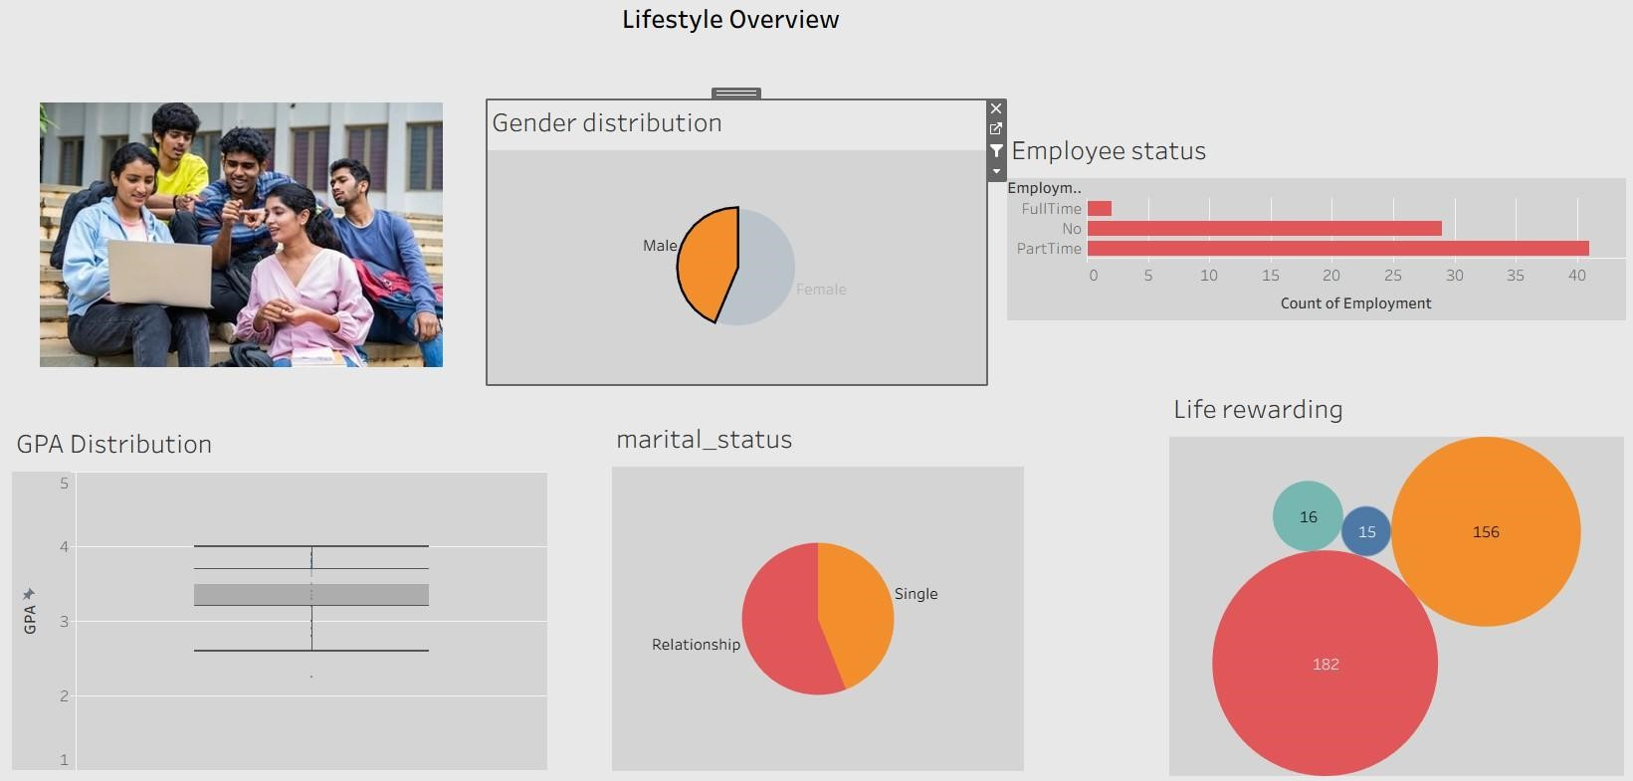

**Selected “Female” as a Filter**

